SQL ASSIGNMENT -12

ROLL NO-84016

Q1Write a query that selects all customers whose ratings are equal to or greater than ANY of ‘Serres’.
Ans.
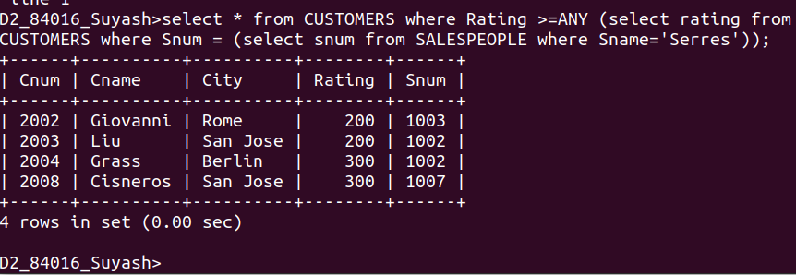

Q2.Write a query using ANY or ALL that will find all salespeople who have no customers located in their city.
Ans.
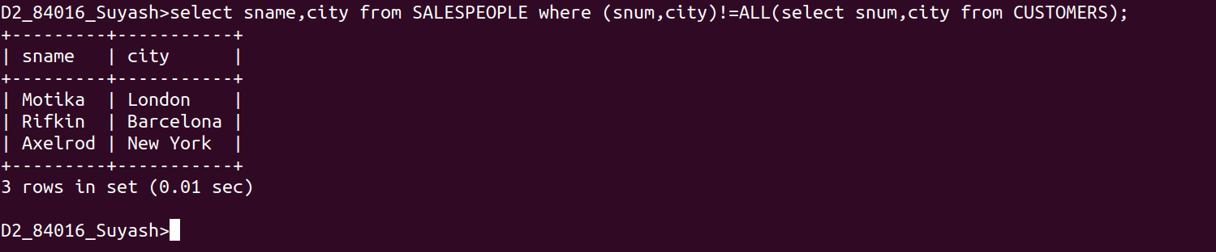
Q3.Write a query that selects all orders for amounts greater than any for the customers in london.
Ans.
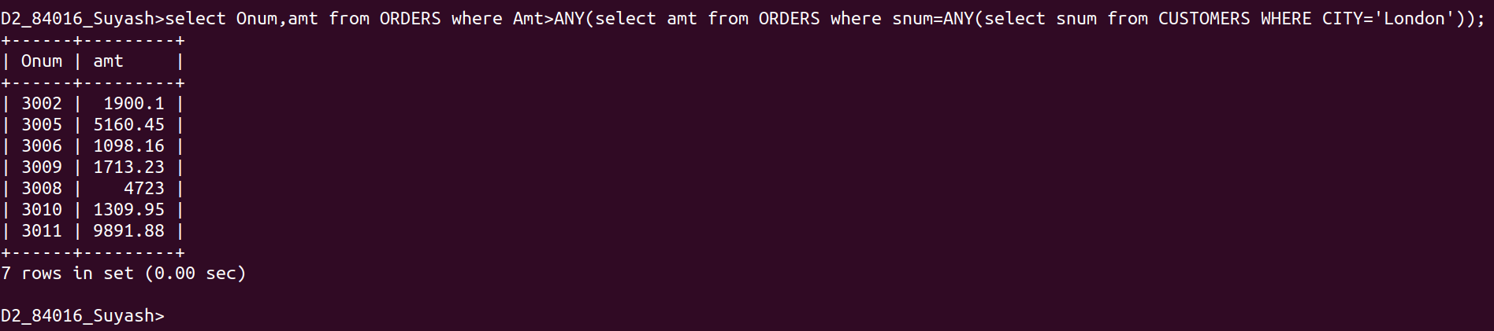

Q4.Write the above query using Min or MAX.

Ans.
